Win $1,000

Compete in the Rotary Club of

________________________________

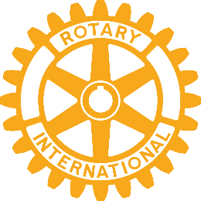

4-Way Test Speech Contest

Freshman through Seniors are Eligible

For Scholarships!

The Clubs of Rotary District 6780 are holding speech contests at the Club and District levels in the winter of 2025. The Club winners will compete at the District level on March 1, 2025, at Ramsey’s Resort and Conference Hotel in Pigeon Forge, Tennessee. The District winner will receive scholarship amounts of $1,000, second place $650 and third place $350.

See: in Room for

information about the Club contest, rules and an entry form. More information can be found on the District 6780 website at www.rotarydistrict6780.com (Tab ‘Youth Service’)

Contestants must sign up no later than , 2024